Preparing Nurses to Actively Engage in Health Policy

Alyssa Nahnsen
Report of Educational Effectiveness
NURS: 4099:1763 Honors Independent Study
Dr. Grossmann
December 8, 2023

Report of Educational Effectiveness
1. Purpose of project:
- Main Topic : Preparing Nursing Students to Actively Engage in Health Policy
  - Specific educational objectives
    - Gauge baseline knowledge and confidence in policy engagement of undergraduate nursing students
      - Discover undergraduate nursing student perception of nursing involvement in policy
      - Assess readiness to find credible sources
      - Provide resources to promote resolution engagement in the next years Iowa Association of Nursing Students (IANS) Convention
2. Methods:
The methods used in this study include two qualitative surveys, with combination open ended questions and Likert scale questions. The first survey was given at the start of the first resolution writing workshop. This was administered at this time to assess baseline knowledge and opinions of nursing students. The second survey was given via QR code at the end of the resolution hearing at the 2023 IANS Convention. This specific time was chosen to determine the impact of the workshop teachings. The results were analyzed through a combination of chart analysis and reading responses.
3. Results:
When looking at the results of the first survey, one student attended the first Zoom workshop, and there was one survey response. This student graduates their nursing program in Spring 2025. The student reported that they strongly (5/5) believed that nurses should be involved in policy and legislation. They reported not feeling confident about researching academic journals (1/5), and reported not feeling confident about writing a resolution (2/5). They reported that they were planning to submit a resolution and that they were strongly confident about engaging in health policy after graduation from nursing school (5/5). When asked were their resolution can make an impact, they offered “nursing school and universities, mental health offices”.
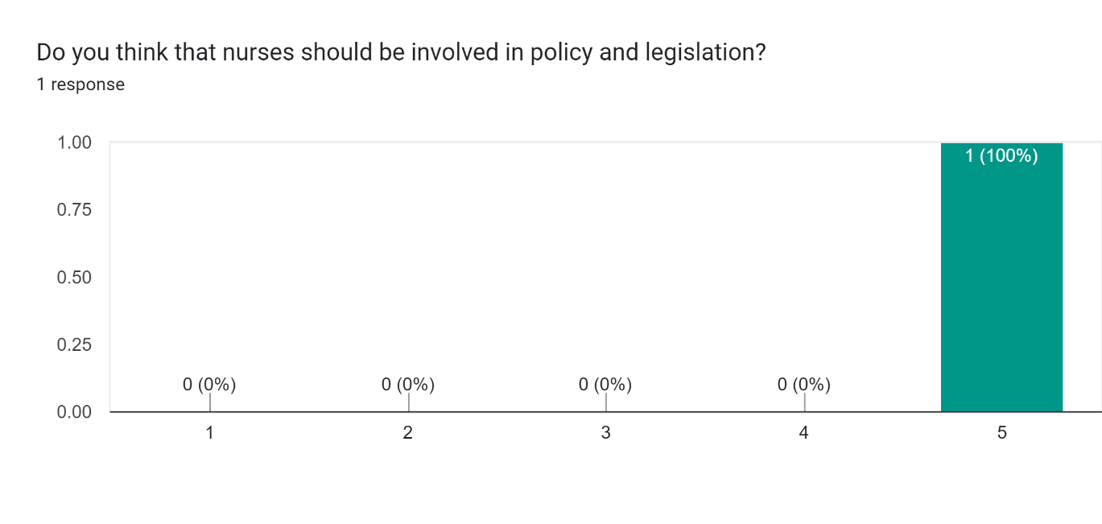

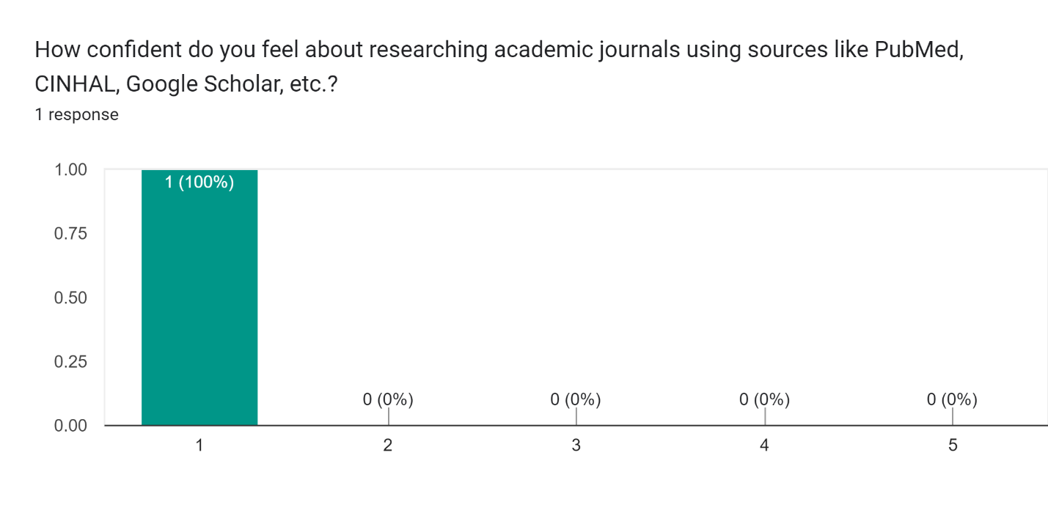
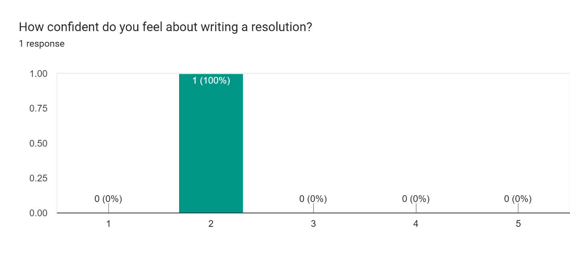
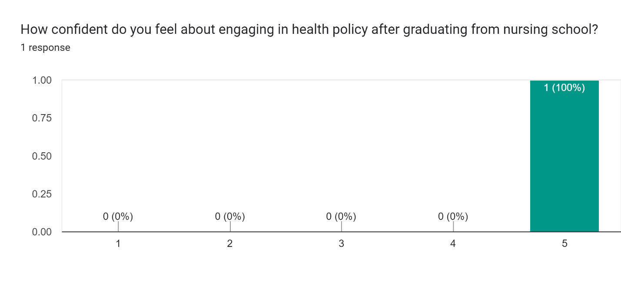

There were 17 responses to the second survey. This survey was accessible to all 160 delegates of the 2023 Annual IANS Convention. Of the responses, 47.1% of students graduate their nursing program in Spring 2024, 29.4% in Spring 2027, 11.8% in Fall 2026, 5.9% in Fall 2023 and 5.9% in Spring 2026.
A majority of students strongly believe nurses should be involved in policy and legislation (70.6%). 11.8% believe that nurses should be involved (4/5 on likert scale). And 17.6% are neutral (3/5).
When assessing confidence in researching data, 5.9% were not confident at all (1/5), 5.9% were not confident (2/5), 17.6% were somewhat confident (3/5), 41.2% were confident (4/5), and 29.4% were very confident (5/5).
Confidence in writing a resolution was lower. 29.4% were not confident at all (1/5), 17.6% were not confident (2/5), 29.4% were somewhat confident (3/5), 17.6% were confident (4/5), and 5.9% were very confident (5/5).
17.6% of students who responded to the survey submit a resolution for the 2023 IANS Convention, while 82.4% of respondents did not.
Students reported either not using resources or struggling with knowing where to find resources. The other half of students reported using the IANS resources provided as well as the NSNA website. Another response gave a suggestion to make writing resolutions a class assignment.
6 out of 11 responses indicated an interest in writing a resolution next year.
When rating confidence about engaging in health policy post nursing school graduation, 17.6% were not confident (2/5), 64.7% were somewhat confident (3/5), and 17.6% were confident (4/5).
Students reported resolutions can make an impact in clinics and hospitals, nursing education programs, and at places of employment.
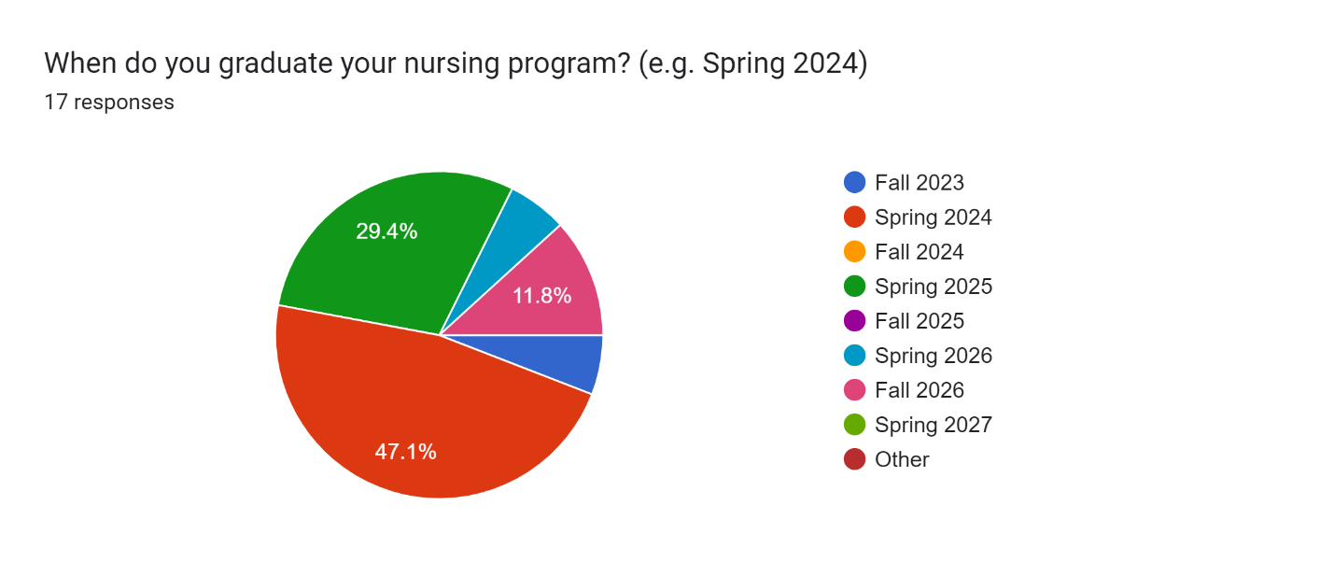
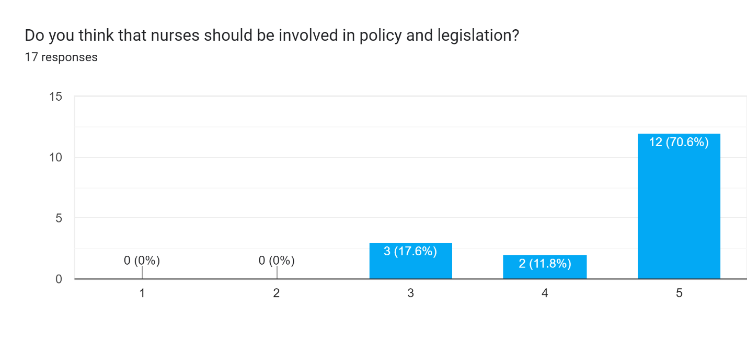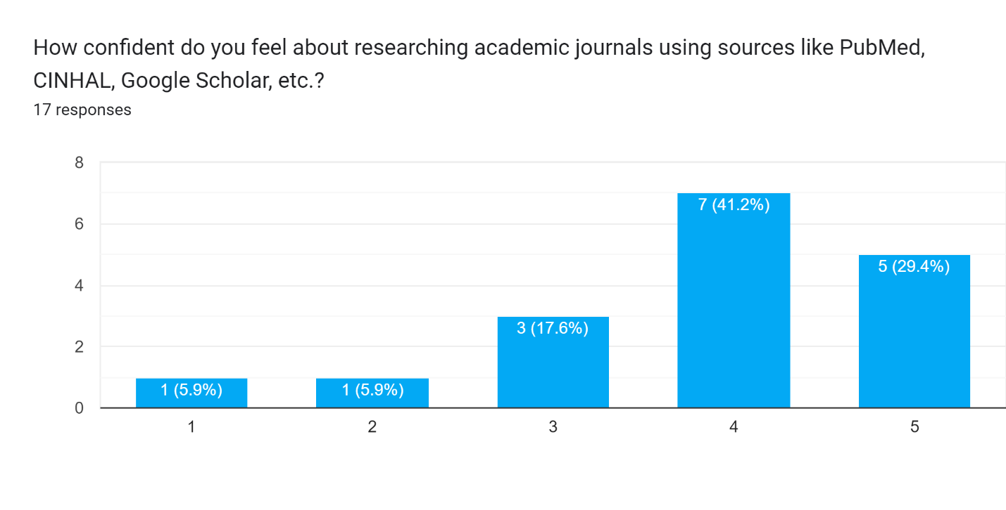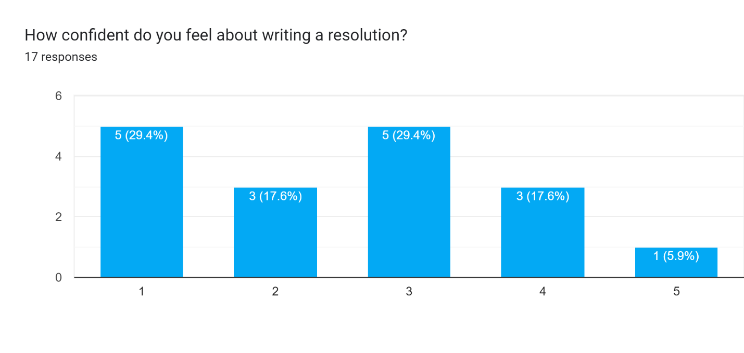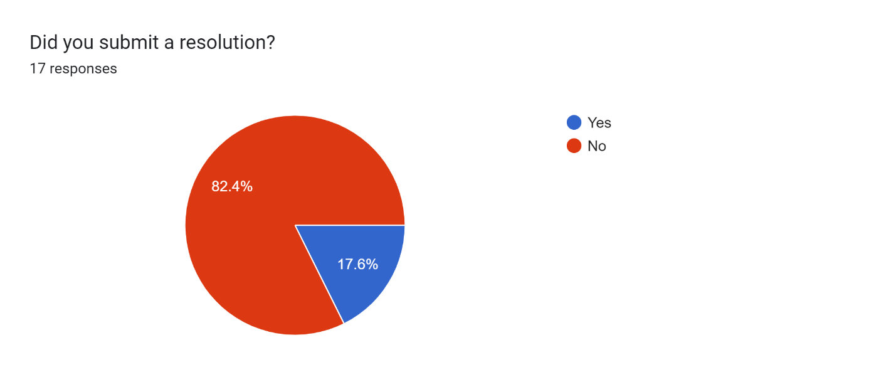
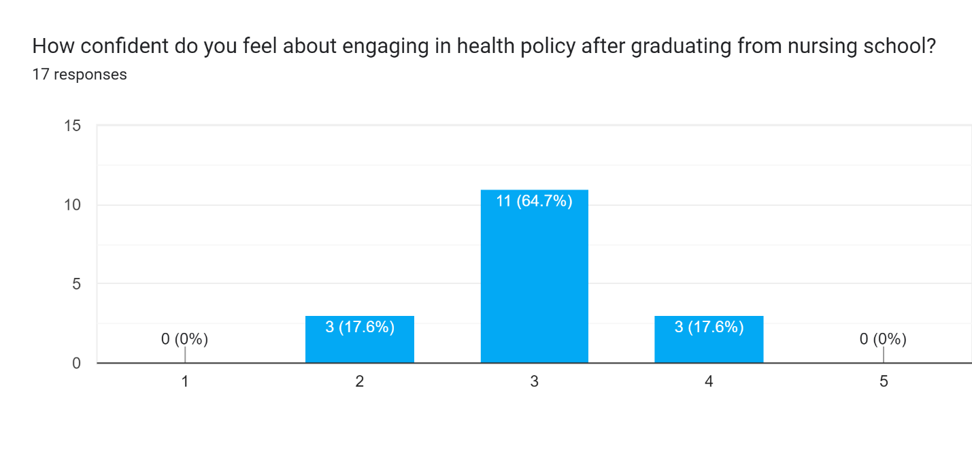
4. Discussion: Evaluation/Interpretation of results
The survey indicates that students need accessible resources and support to build their confidence in health policy involvement. There is a discrepancy between the number of students that believe that nurses should be involved in policy and legislation and their preparedness and confidence levels. Because a majority of the undergraduate nursing students surveyed, (70%), strongly believe nurses should be involved in policy and legislation, much is to be done to develop their preparedness to involve themselves post-graduation. Additionally, students reported not feeling confident using research databases to find credible sources. They also reported low confidence in writing resolutions, which is a mirror of what they will do in policy post graduation. A poor response rate may indicate demonstrate that there is a low interest in health policy amongst undergraduate nursing students. The poor response rate proves that there is much to be done to spark interest and involvement of undergraduate nursing students in health policy.

